PERSONAL PROFILE

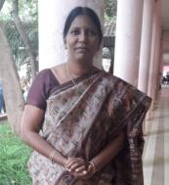
Name: MSK KRISHNA JYOTHI
Designation:Lecturer in History
College Address:SRR&CVRGovtDegreeCollege(A),Vijayawada
CellNo: 9110728070
Mail Id:mskkrishnajyothi@gmail.com
Educational Qualifications
S.NO | COURSE | BOARD/  UNIVERSITY | YEAROF  PASS | PERCENTAGE
1 | S.S.C. | BOARDOF  SECONDARY  EDUCATION | 1990 | 61%
2. | INTERMEDIATE | BOARDOF  INTERMEDIATE  EDUCATION | 1990-1992 | 61%
3 | B.Sc.  MBF(Microbiology  Biochemistry  Food&Nutrition) | Andhra  University | 1993-1996 | 76%
4 | M.Ed.  Biochemistry | KSOU  University | 2002-2004 | 64%
5 | MA History | BRAOU  University | 2012 | Distinction

Professional Experience:
1. Worked as a School assistant in Zilla Praja Parishad Schools in SPSR Nellore for 17 years
2. Joined as a Lecturer in History in SRR & CVR Government Degree College on 07-06-2018
Orientation Course:
Completed with A+ grade from June 26th to July 24th, 2020 with Teaching Learning Centre, Ramanujam College, University of Delhi (online)
Refresher Course:
Completed with A+ grade from 11th to 26th of March 2021 with Teaching Learning Centre, Ramanujam College, University of Delhi (online)
Workshops/FDPs attended:
- History Matters: The past, present and future-social, cultural, political & economic foundations from 20th July to 24th July 2020 conducted by Commissioner of Collegiate Education.
- 5 day FDP in LMS Video & Pedagogy from 3rd August, 2020 to 7th August 2020 conducted by Commissioner of Collegiate Education.
- 3 Day FDP on Podcast held from 12th to 14th August 2021 organised by APSHE, Government of AP in association with Commissionerate of collegiate Education, A.P.
International:
- Domestic Violence an International oneday workshop held on 13th December 2018 at Sri Durga Malleswara Siddhartha Mahila Kalashala, Vijayawada.
- Kamala Nehru College University of Delhi conducted two days International webinar titled, “Dil-O-Dilli” by Department of History in Association with INTACH on 11th and 12th June, 2020.
National:
1. Viswanatha Sahitya Samalochana National seminar at SRR & CVR Degree College 7th &8th September 2018.
2. Varanasivari Geyakavitha Vaibhavam oneday workshop at SRR & CVR Degree College on 5th December 2018.
3. One week Workshop on Teaching and Learning for Sustainability from 14-11-2-19 to 20-11-2019.
4. One day National Webinar on “Impact of Covid-19 on Indian Economy: Surval strategies for Banking, Education, Pharma and Retail Secotrs” on 19-05-2020 conducted by the department of Economics, SRR&CVR Governemnt Degree College.
5. Two days National seminar on “Impact of covid-19 on the Migrant labour in India” on 26th & 27th February, 2021 at Ideal College of Arts and Science, Kakinada.
Few Achievements and Awards:
1. Stood second in Woman General Category in DL recruitment by APPSC
2. Received Paryavaran Mitra best Teacher from honourable ex-President Sri APJ Abdul Kalam in the year 2010.
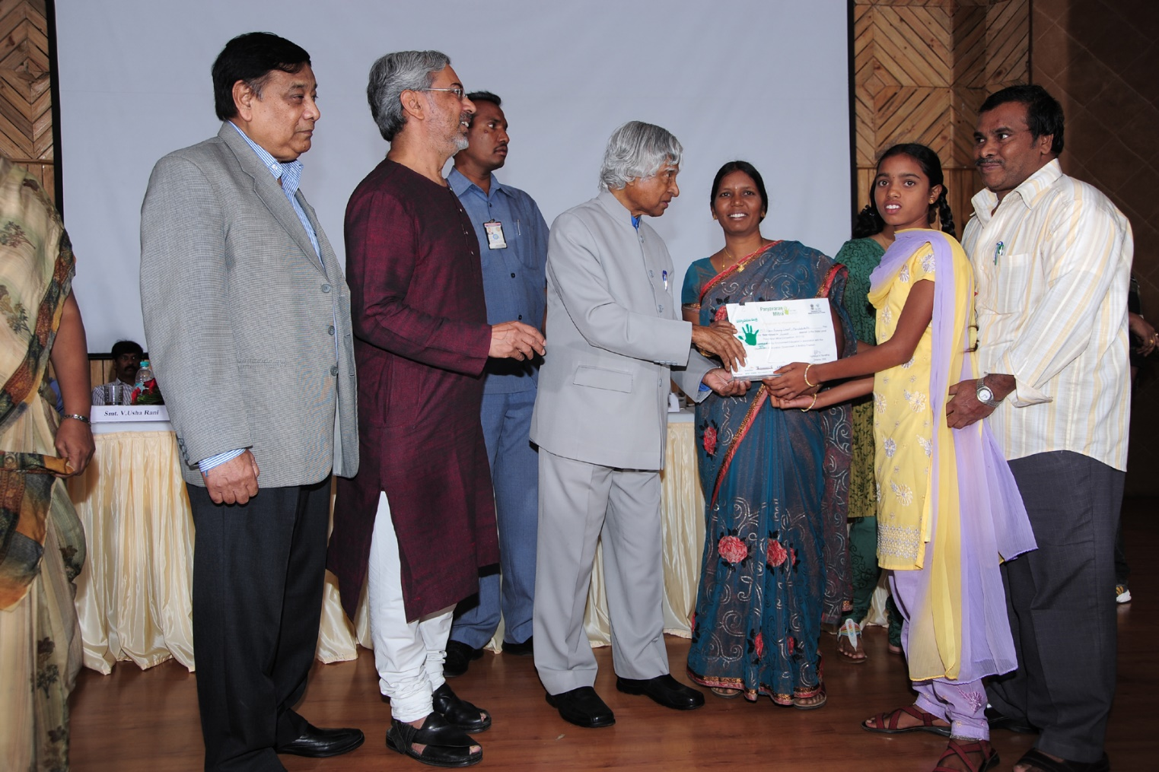
Receiving Paryavarana Mitra Award from Dr.APJ Abdul Kalam

- Received Best Poetess National Award on 2-11-2015 from Dr.C.Narayana Reddy the most famous Telugu Poet. The poetry competition was held by Sri Kiran Cultural association, Hyderabad.

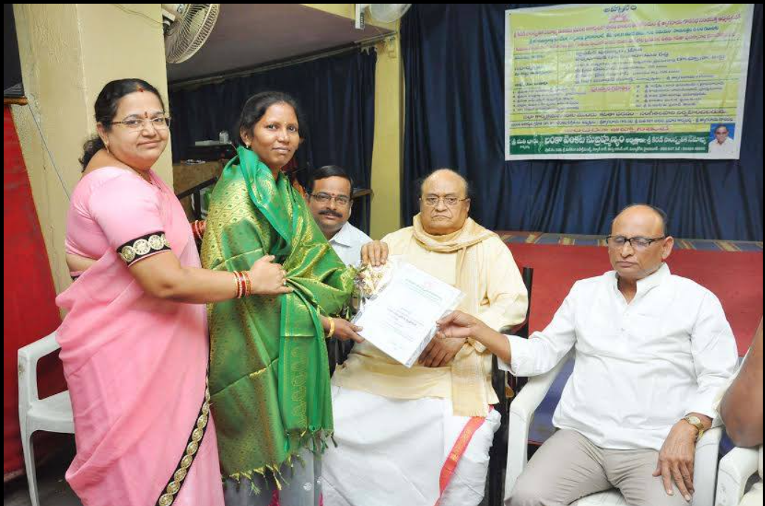

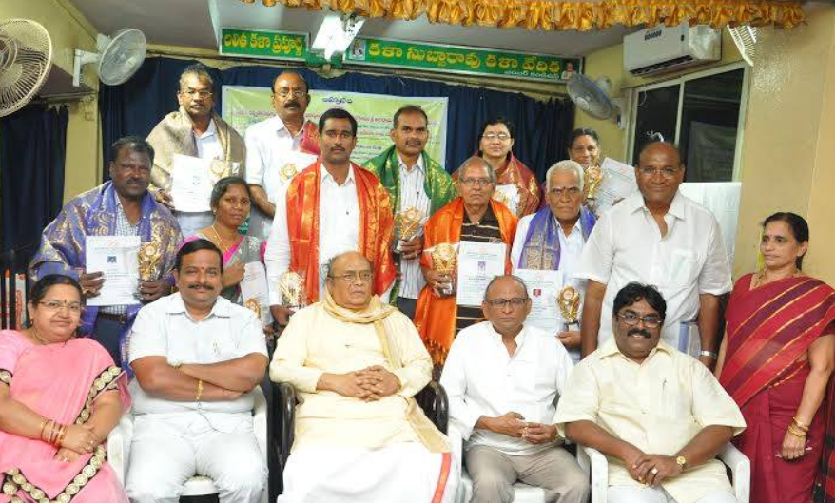

- Received Prestigious Raavishastri National Award from the able hands of Goreti Venkanna, Sahitya Academy Award Winner. Raavishatri was a great Telugu story writer famous for his outstanding pun and social awareness.
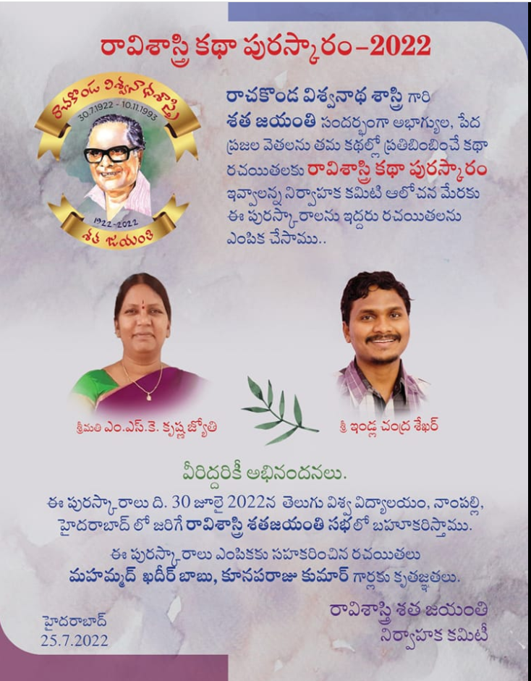

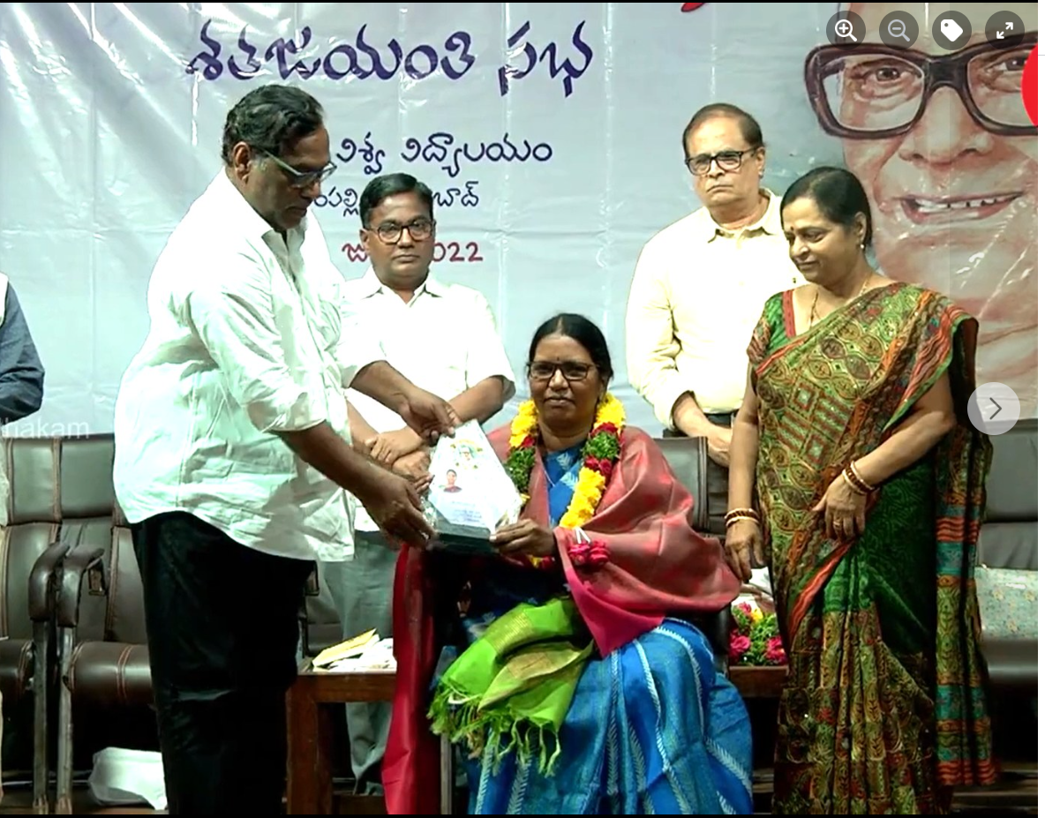
Few important Publications:

- Telugu Teeseste Nashtame, Telugu Velugu, September 2020, ISSN 2582-1539
- Impact of Covid-19 on the Migrant Labour in Health Hygiene and Hazards of Viral Spread, 26th, 27th Feb, 2021, ISBN: 978-81-94706144.
- Municipal Towns of West Godavari District and History of their Formation; 2022 IJRAR December 2022, Volume 9, Issue 4
- Antique remains of Literacy in Ellore; February 2023 | IJIRT | Volume 9 Issue 9 | ISSN: 2349-6002

Few Books:
- A book titled, Kottapandaga was published in 2019. It was a compilation of short stories published in different magazines for four years. The book got great applause.
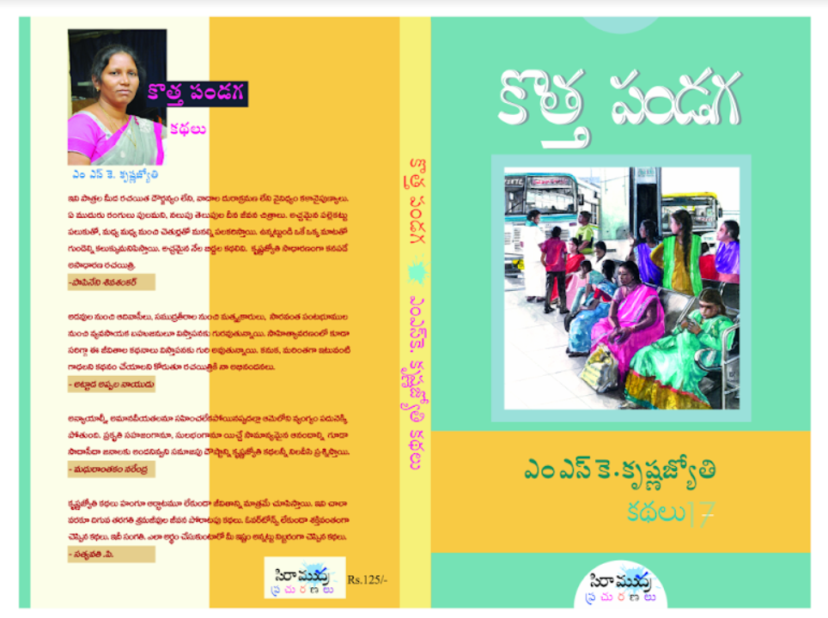

- Ocean Boy, Short story published in The Best Stories of Our Times, Edited by Volga, Translated by Alladi Uma and M Sridhar, from the prestigious Harper Perennial publications, 2022, ISBN: 978-93-5489-343-8.
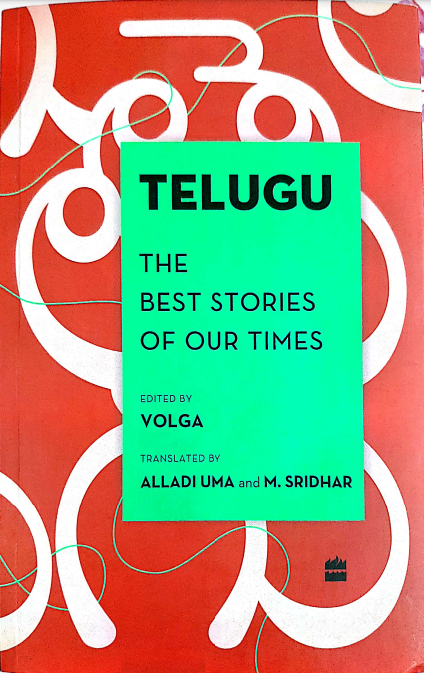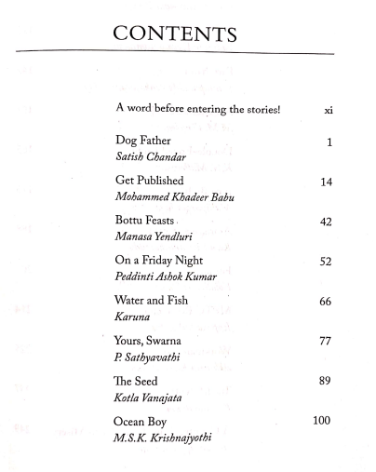

- Telugu Logillalo Pashu Pakshyadula Kathalu, 2022 November
